GAN Architecture
➔ Explain the adversarial process in GAN training:
- A GAN (Generative Adversarial Network) has two neural networks:
  - Generator (G): Tries to generate realistic fake data.
  - Discriminator (D): Tries to distinguish between real and fake data.
- They are trained simultaneously:
  - The Generator aims to fool the Discriminator.
  - The Discriminator aims to correctly classify real vs. fake.
- This is a zero-sum game:
  - Generator's success = Discriminator's failure, and vice-versa.
  - Over time, the Generator becomes better at creating realistic outputs.

➔ Goals:
Component | Goal | Loss minimized/maximized
Generator | Generate realistic samples | Minimize discriminator's ability to detect fakes
Discriminator | Detect fake samples correctly | Maximize accuracy between real and fake

➔ Diagram of GAN Architecture:
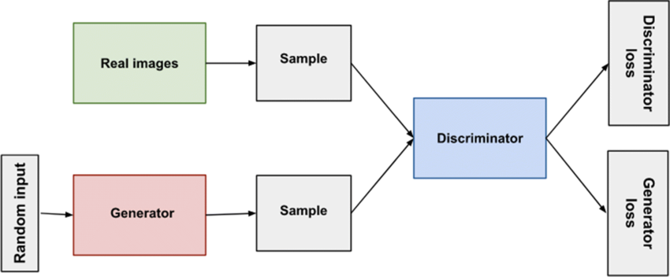
- Generator input: Random noise (z).
- Generator output: Fake data (G(z)).
- Discriminator input: Both real data and fake data.
- Discriminator output: Probability (real/fake).

